Solar Generation for Remote Borefields

Team 12

Authors

Steven Bardzovski (21121998)

Individual Final Report

Project Partners: Jacobs

Demonstrator: Catherine Hatch

Academic Supervisor:

Dr. Sally Male

Group Meeting Day and Time: Friday 12 pm

Word Count: 3,314

Word Limit: 3,500

Version 1.4

Revision History

|  |  |  |  |
| --- | --- | --- | --- |
| **Date** | **Version** | **Description** | **Author** |
| 12/05/2017 | 1.0 | Initial format of document | Steven Bardzovski |
| 14/05/2017 | 1.1 | Draft introduction added | Steven Bardzovski |
| 15/05/2017 | 1.2 | Introduction and Contributions added | Steven Bardzovski |
| 16/05/2017 | 1.3 | Hybrid section added | Steven Bardzovski |
| 17/05/2017 | 1.4 | Final Edit | Steven Bardzovski |

Table of Contents

1. Introduction 4

1.1 Purpose 4

1.2 Scope 4

1.3 Definitions, Acronyms, and Abbreviations 4

1.4 References 4

2. Updated Requirements 5

3. Design Philosophy 5

4. Hybrid – PV, Battery and Diesel Generator 5

4.1 Elements 5

4.2 Methodology 6

4.3 Results 8

5. Individual Learning 9

6. Contribution 9

7. Appendices 11

7.1 Appendix A – Requirements Analysis 11

# Introduction

## Purpose

The previous documents, Requirements Analysis (RA) and Design Analysis (DA), have outlined the requirements of the projects ranking them in order of priority and importance to the successfully completion of the project and the outlined possible design solutions including proposed testing and costing analyses of each solution. The purpose of the Final Design report (FD), is to outline in the detail all the elements, including inputs, outputs, costs and safety of the proposed design solutions outlined in the DA. The FD also includes a justification of the optimal proposed solution. The Individual Final Design (IFD), this report, will outline the sections of the FD that were undertaken by Steven Bardzovski along with the authors contributions to the FD and contributions within the team.

## Scope

The scope of the group Finial Design report consists of all of the elements involved with each proposed solution including the base case. The FD will outline the voltage and current characteristics for each transmission line including safety features such as circuit breakers and isolators at different points of the system. An extensive cost analysis will also be presented in the FD including values such as capital costs, operation and maintenance (O&M) costs, repair costs and NPV. After discussing the elements and costs of each proposed system one will be chosen as the system to be implemented and a justification of this will be outlined.

The scope of this IFD report however will only contain a portion of the content of the group FD report, in particular the portion of the FD written by Steven Bardzovski. The hybrid proposed systems will be discussed in detail in the following report. This includes all assumptions, calculations and simulations for sizing each piece of technology for the two systems. Naturally after sizing each system appropriate transmission cables and safety features such as isolators and circuit breakers must be chosen, along with a cost analysis of each system. However, this IFD report will not cover these sections, rather they will be covered in the group FD report.

## Definitions, Acronyms, and Abbreviations

|  |  |
| --- | --- |
| Acronym | Definition |
| DA | Design Approach |
| FD | Final Design |
| HOMER | Hybrid Optimization Model for Electric Renewables |
| IFD | Individual Final Design |
| RA | Requirements Analysis |

## References

[1] Landcorp, "Part 3 Newman," in *Pilbara Vernacular Handbook*, ed Australia, 2015.

[2] J. F. Manwell and J. F. Q. J. F. Manwell, *Wind Energy Explained Theory, Design and Application*, 2nd ed. ed. Hoboken: Wiley, 2010.

[3] X. Wang, P. Adelmann, T. Reindl, X. Wang, P. Adelmann, and T. Reindl, "Use of LiFePO4 Batteries in Stand-Alone Solar System," *Energy Procedia,* vol. 25, pp. 135-140, 2012.

# Updated Requirements

After completing the RA, confusion about the nomenclature of some of the requirements were brought to the attention of Team Power. An updated copy of the requirements including their priority, description, classification, and origin can be found in Appendix A. Requirements (1), (2), and (3), previously named 24/7, 90 kW and Newman, respectively have been changed to avoid confusion about what the requirement is stating and using the name of the requirement when not referring to the requirement itself. For example, requirement (3) was previously named Newman, which caused confusion when mentioning the location of the borefields.

# Design Philosophy

The DA report, completed by Team Power, outlined three proposed solutions, along with the base case, to power the remote borefields. The base case involved connecting the pumps to the grid view the mine site located 10 km away from the borefield. The three proposed solutions consisted of two hybrid systems and a purely renewable system. Hybrid 1 was a photovoltaic (PV), battery storage, and diesel generator back-up system, Hybrid 2 was a PV, wind, battery storage and diesel generator back-up system and the purely renewable system contained PV, wind and battery storage. Team Power chose these solutions based on preliminary research into the types of technology and the location of the borefield and their extent to meet the requirements. However, after submission of the DA and further extensive research into the technologies and location the proposed solutions were modified.

After further research into the weather conditions at the location of the borefields (Newman, Western Australia) it was discovered that the average morning wind speed was 9.1 km/h (2.5 m/s) and the average afternoon wind speed was 9.4 km/h (2.6 m/s) [1]. The cut-in wind speed of a turbine is the minimum wind speed required for the turbine to overcome internal frictions and produce useful power, this is usually around 4-5 m/s but varies based on the wind turbine [2]. The average wind speeds in Newman were lower than the average cut-in speeds of wind turbines and hence the use of wind turbines would be inefficient for the successful completion of the project. It was therefore decided by Team Power to remove Hybrid 2 as a possible solution for the project and the wind turbines from the purely renewable solution be removed from the design. This left the purely renewable system consisting of only PV and battery storage however the Team decided that this system would not be reliable as a standalone system and therefore it was removed as a possible solution. After revisiting the requirements, it was noted that being environmentally friendly was a low requirement (9) for the project and that economics was a higher requirement (5). This lead Team Power to propose a purely diesel generator system as the second solution for powering the remote borefields.

# Hybrid – PV, Battery and Diesel Generator

## Elements

The main elements of the hybrid system include, solar panels, batteries, boost converters, inverters, diesel generator, and regulators. Although not covered in this report the Hybrid system must also include transmission lines capable of caring the various voltages and currents and safety features such as circuit breakers and isolators. A telemetry system must also be included in the Hybrid system to monitor the operation the PV, battery bank and overall system and relay information to the mine site. Fencing and shelter must be implemented to protect the system from external factors such as animals and harsh weather conditions.

## Methodology

The following sections outlines the steps that were involved in sizing the PV, battery storage and diesel generator, including assumptions. This section will be structured to accommodate rapid re-calculation of specific values when changes in the requirements arise during later stages of the project lifetime. Figure 1 is block diagram representation of the electrical flow of the system and not a spatial representation of the components in the system. The Load represents the three bore pumps each of 30 kW alternate current (AC) power rating and the telemetry system of 100 W power rating. The PV array produces direct current (DC) power and hence an inverter was added to convert the DC to AC. The DC/DC boost converter was added to allow for a lower PV array and battery output voltage to power the load.

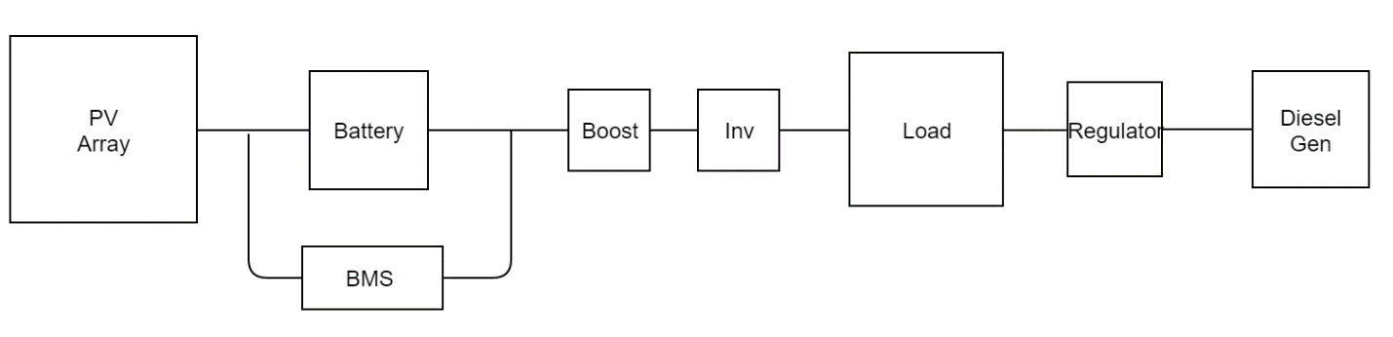

Figure 1: Block diagram of electrical flow of system

The requirements analysis (Appendix A) completed by Team Power in RA report had prioritised cheaper solutions (requirement (5)) over environmentally friendly solutions (requirement (9)) however the Team decided to optimise the solutions green factor as an innovative incentive for the client. From this decision assumptions were made on the operating capability of the system. The first assumption was that the battery bank would be capable of providing power to the load for eight hours without the use of the generator. The second assumption was that the PV array would be sized to supply six hours of power to load along with the ability to completely charge the battery bank during the day. This would mean that the renewable portion of the system would power the pumps for 58 % of the day.

Team Power considered two possible connection for the renewable portion of the hybrid system. The first consisted of one inverter, one boost converter, one battery bank and one PV array to power the entire 90 kW load similar to the block diagram depicted in Figure 1. However, when connecting batteries in parallel variability in the string voltages could cause discharge problems throughout the battery bank and therefore the amount of strings should be kept to a minimum. This connection also left the system with a higher probability of failure, for example, if the inverter were to fail the renewable portion of the system would not be able to supply power to the load. Team Power, therefore, decided on a connection that consisted of an inverter, boost converter, battery bank and PV array per pump as depicted in Figure 2. The layout of this system allows the use of smaller inverters, boost converters and fewer battery strings and therefore an overall more reliable system. Although each pump is connected to its own inverter, booster, battery bank and PV array, spatially these components will be located very close to one another.

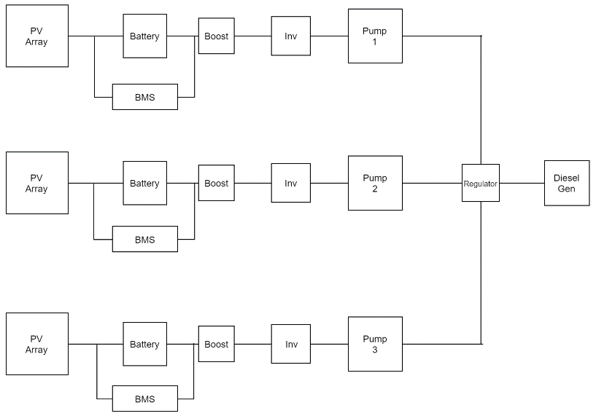

Figure 2: Block diagram of proposed system

The pumps specified by the client were the Grundfos MMS6000 30 kW submersible pumps and therefore the output power from the inverter was required to be 30 kW 3 phase power. Assuming an amplitude modulation ration ma of 0.85 the required input voltage for the inverter can be calculated using the following equation where VLL represents the line to line voltage of the output (415 V for the pumps). The inverter was assumed to have 85% efficiency.

$$V_{in, inv}= \frac{2\sqrt{2 }V_{LL}}{m_{a}\sqrt{3}}$$

The step-up DC/DC converter would therefore have an output voltage equivalent to the input of the inverter because the converter would be located close to the inverter which would result in legible loss. The input voltage of the boost converter was calculated using the following equation with a duty ratio D of 0.5. The efficacy of the boost converter was assumed to be 100%.

$$V_{in,boost}=V_{out}(1-D)$$

The batteries chosen for the system were 12 V at 100 Ah lithium iron phosphate (LIP) batteries. Other options considered by Team Power included lead acid and lithium ion batteries however the LIP batteries are safer than lead acid and have better temperature tolerance than lithium ion batteries [3]. Assuming 80% depth of discharge of the batteries the number of batteries in series and number of strings can be determined using the equations listed below, where it was assumed the batteries would have the capability to power the pump for 8 hours.

$$Number of batteries in Series= \frac{V_{in,boost}}{V_{battery}}$$

$$Number of Strings= \frac{P_{in,boost} × hours of pump opertation}{V_{battery} × 100 Ah × 80\%}$$

As mentioned previously Team Power had decided to size the PV array to be able to produce enough energy to power the pumps for six hours and charge the battery bank. The solar panels chosen were Sunmodule SW300 with rated voltage at 32.6 V and rated current at 9.31. The average solar insolation of 6.1 kW/m2 for Newman was obtained from the Bureau of Meteorology (BOM) which is equivalent to 6.1 hours at peak sun (1 kW/m2). Using this information and the equations below the number of panels in series and number of strings in the PV array were determined. A derating factor of 0.8 was assumed for the PV array due to dust.

$$Number of batteries in Series= \frac{V_{in,battery}}{V_{PV}}$$

$$Number of Strings= \frac{P_{in,battery} ×(hours of pump operation and battery charge)}{V_{PV} × I_{PV} × hours at peak sun × derating factor}$$

After taking a mathematical approach to sizing the Hybrid system was simulated on using the hybrid optimization model for electric renewables (HOMER) software. The HOMER software calculates all possible combinations of the input variables and ranking the feasible results in order of net present cost (NPC). Solar insolation, wind speeds and temperature ranges were downloaded from the HOMER data base after imputing the location of the borefields. A 95-kW load was added to the simulation, where the extra 5 kW were to be used for telemetry and lighting. Input variables added to the simulation included the diesel generator, PV array, converter, and battery bank. Each input had a variable range of values that HOMER would use to optimise the overall system. Although HOMER is capable of determining the optimum size of each technology in the Hybrid system, it does not output the voltage and current relationships for each technology, hence these would need to calculated manually.

## Results

Table 1 represents a summary of all the input and output voltages, currents and power of each technology in the renewable connection of the system. These values were determined using the methodology outlined in the section about and can be easily recalculated if changes occur in a later stage of the project lifecycle. Table 2 outlines the amount of batteries and solar panels required in series and number of strings. As mentioned previously the renewable portion of the system was separated into three legs with each pump connected to an inverter, converter, battery bank and PV array and the total number of elements in Table 2 is the sum of all three legs. The diesel generator would be required during periods when the PV array and battery power are insufficient to power the pumps and therefore the size of the generator would be governed by the peak load power. Assuming 85 % efficiency the Hybrid system would require a 110 kW to provide sufficient power to run the pumps.

Table 1: Summary of input and output values of renewable portion of the system

|  |  |  |  |  |  |  |
| --- | --- | --- | --- | --- | --- | --- |
|  | Vin (V) | Vout (V) | Iin (A) | Iout (A) | Pin (kW) | Pout (kW) |
| Inverter | 800 | 415 | 44 | 63 | 35 | 30 |
| Boost | 400 | 800 | 88 | 44 | 35 | 35 |
| Battery | 400 | 400 | 88 | 88 | 35 | 35 |
| PV | - | 400 | - | 88 | - | 35 |

Table 2: Battery and PV size

|  |  |  |  |
| --- | --- | --- | --- |
|  | Number of elements in series | Number of strings | Total number of elements |
| Battery | 34 | 9 | 918 |
| PV | 13 | 27 | 1053 |

Table 3 summerises the size of each technology in the hybrid system as simulated by the HOMER software. These values are lower than the values calculated above because the approach used by the HOMER software involved ranking the systems based on NPC. The HOMER simulation did not take into account the assumptions made for the battery autonomy and therefore the percentage of renewable energy production was much lower than that using the method stated above. Although the final decision will be weighted more on the NPC of the system (not covered in this document), these two methods allow the client to compare the relationship between economic and environmental. If, for example, the NPCs of the two methods were almost equal the client could be excited into implementing the more innovative (renewable) system.

Table 3: Size of technologies using HOMER simulation

|  |  |
| --- | --- |
| PV (kW) | 175 |
| Diesel Generator (kW) | 110 |
| Lithium Ion Batteries | 400 |

The results obtained using the two methods ensured that the proposed hybrid system had met requirements (1) and (2), that is, the system will be capable of providing continuous power to the pumps and the power generation of the system would be over 90 kW. The specific solar panels and batteries were chosen to meet requirement (3) and (4) allowing the system to operate as safely as possible in the desired location. However, overall safety procedure will need to be determined for the system as a whole.

# Individual Learning

The most significant learning outcome Steven Bardzovski has achieved in the lifetime of the project design is being able to apply technical knowledge and problem solving skills to achieve a desired outcome that satisfies the requirements. Steven has demonstrated this through the sizing of the Hybrid system (this report) and the purely generator system (FD report). The use of prior knowledge in circuit theory, renewable energy, and power electronics has allowed Steven to complete this task. Steven applied logical reasoning acquired from previous studies to guide his methodology and critically analysis of the final results.

# Contribution

The requirements of the group FD were listed and delegated equally to the six members of Team Power, based on hours required to complete each task. Steven Bardzovski was given the task of sizing the two proposed solutions, the hybrid and solely diesel generation systems. This included the inverters and converters required in the transmission of the generated power. Steven’s background in mathematics was one of the reasons why he was given this section of the report. Although, these calculations were completed by Steven, after every set of calculations the Team was consulted on the accuracy of the results. Steven was also responsible for the simulations of the system on the HOMER Energy software, as he was one of the only members familiar with the program and therefore it would optimise the Teams efficiency to have Steven complete this task. Although the above were Steven’s primary responsibilities he has also consulted with other members in the group as elements in his tasks are crucial in the elements of other tasks.

Steven’s knowledge on renewable energy has been crucial in the successful completion of the project and this knowledge has become particular useful in the completion of the IFD and FD reports. Practical questions involving the tilt and arrangement of solar panels were quickly resolved and calculations for sizing renewable systems were easier to complete due to Steven’s knowledge. As mentioned in previous reports, Steven had volunteered to regulate the file sharing platform and version control using the online software GitHub and Google Drive. Although team members were allocated separate tasks to complete, all members required interfacing with each other to refer to other sections of the system in their individual submissions. Successful interfacing could only be achieved by having a well organised file sharing platform.

# Appendices

## Appendix A – Requirements Analysis

|  |  |  |  |  |
| --- | --- | --- | --- | --- |
| Priority | Description of Requirement | Description | Classification | Origin |
| 1 | Operate continuously (24/7) | The power generation system is required to operate for 24 hours a day, 7 days a week, 365 days a year. | EXP, SPO | Design brief |
| 2 | At least 90kW of power available | The mine site requires maintenance of a 3ML storage tank with expected usage of 900 ML per year. This will require 90 kW of power to drive three 30kW pumps. The pumps are maintained by the client and so the team requirement is to supply 90 kW of power. | EXP, SPO | Initial meeting with Jacobs |
| 3 | Operate in desired location. | The power generation system must operate in Newman. This includes tolerating the harsh conditions and remote environment. | EXP, SPO | Design Brief |
| 4 | Safety | The system must run safely. Any safety equipment that requires power must also be supplied. | EXP, SPO, UNS | Standards, code of practice, expectations and ethics |
| 5 | Economy | Maximise the economy of the proposed solution. | EXP, SPO | Design brief and the initial meeting with Jacobs |
| 6 | Telemetry | The system requires telemetry and communications equipment, and these will also require power. | EXP, SPO | Initial meeting with Jacobs |
| 7 | Maintainable | The system must be maintainable. | EXP, UNS | Standards and code of practice |
| 8 | 10-year life | The system must last for at least ten years | EXP, SPO | Initial meeting |
| 9 | Environment | The proposed solution should minimise harm to the environment. | EXP, EXC | Ethics |
| 10 | Time | The proposed solution should take a minimum amount of time to construct. | EXP, EXC | Arises from requirement 5 (economy) |